Project Development Phase

Date | 21 February 2025
Team ID | LTVIP2026TMIDS86089
Project Name | Order On The Go: Your On-Demand Food Ordering Solution
Maximum Marks

1. Introduction
- Briefly describe the purpose of the development phase.
- State the tech stack (MERN: MongoDB, Express.js, React.js, Node.js).
- Mention your development environment (VS Code, GitHub, MongoDB Atlas, etc.).

2. Development Setup
- Tools & Frameworks: List IDE, version control (Git), libraries used (React Router, Mongoose, etc.).
- Configuration: Document npm scripts, environment variables, and backend server setup.
- Dependencies: Provide a table of major dependencies (e.g., React, Express, Mongoose, Stripe API).

3. Module Development
Break down features into modules and explain how you developed them:
- User Authentication: Registration, login, JWT tokens, bcrypt for password hashing.
- Product Catalog: Fetching products from MongoDB, displaying with React components.
- Cart Management: Add/update/remove items, linked to user ID.
- Order Placement: Checkout flow, payment gateway integration.
- Notifications: Firebase Cloud Messaging for order updates.
- Admin Dashboard: CRUD operations for restaurants/products, order monitoring.

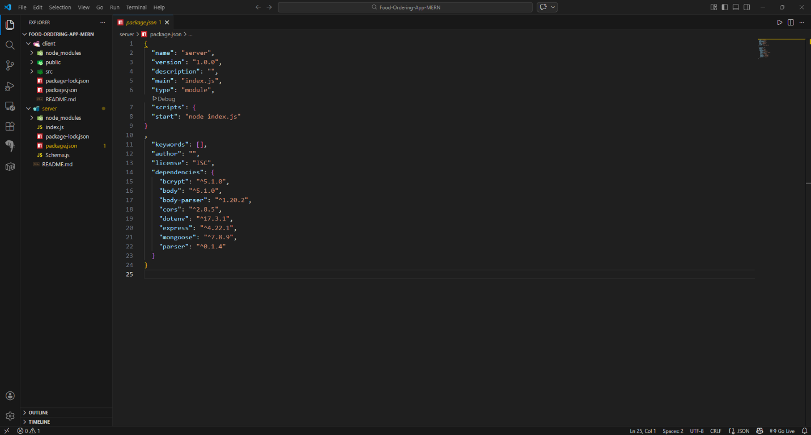

4. Testing
- Unit Testing: API endpoints tested with Postman or Jest.
- Integration Testing: End-to-end order flow tested.
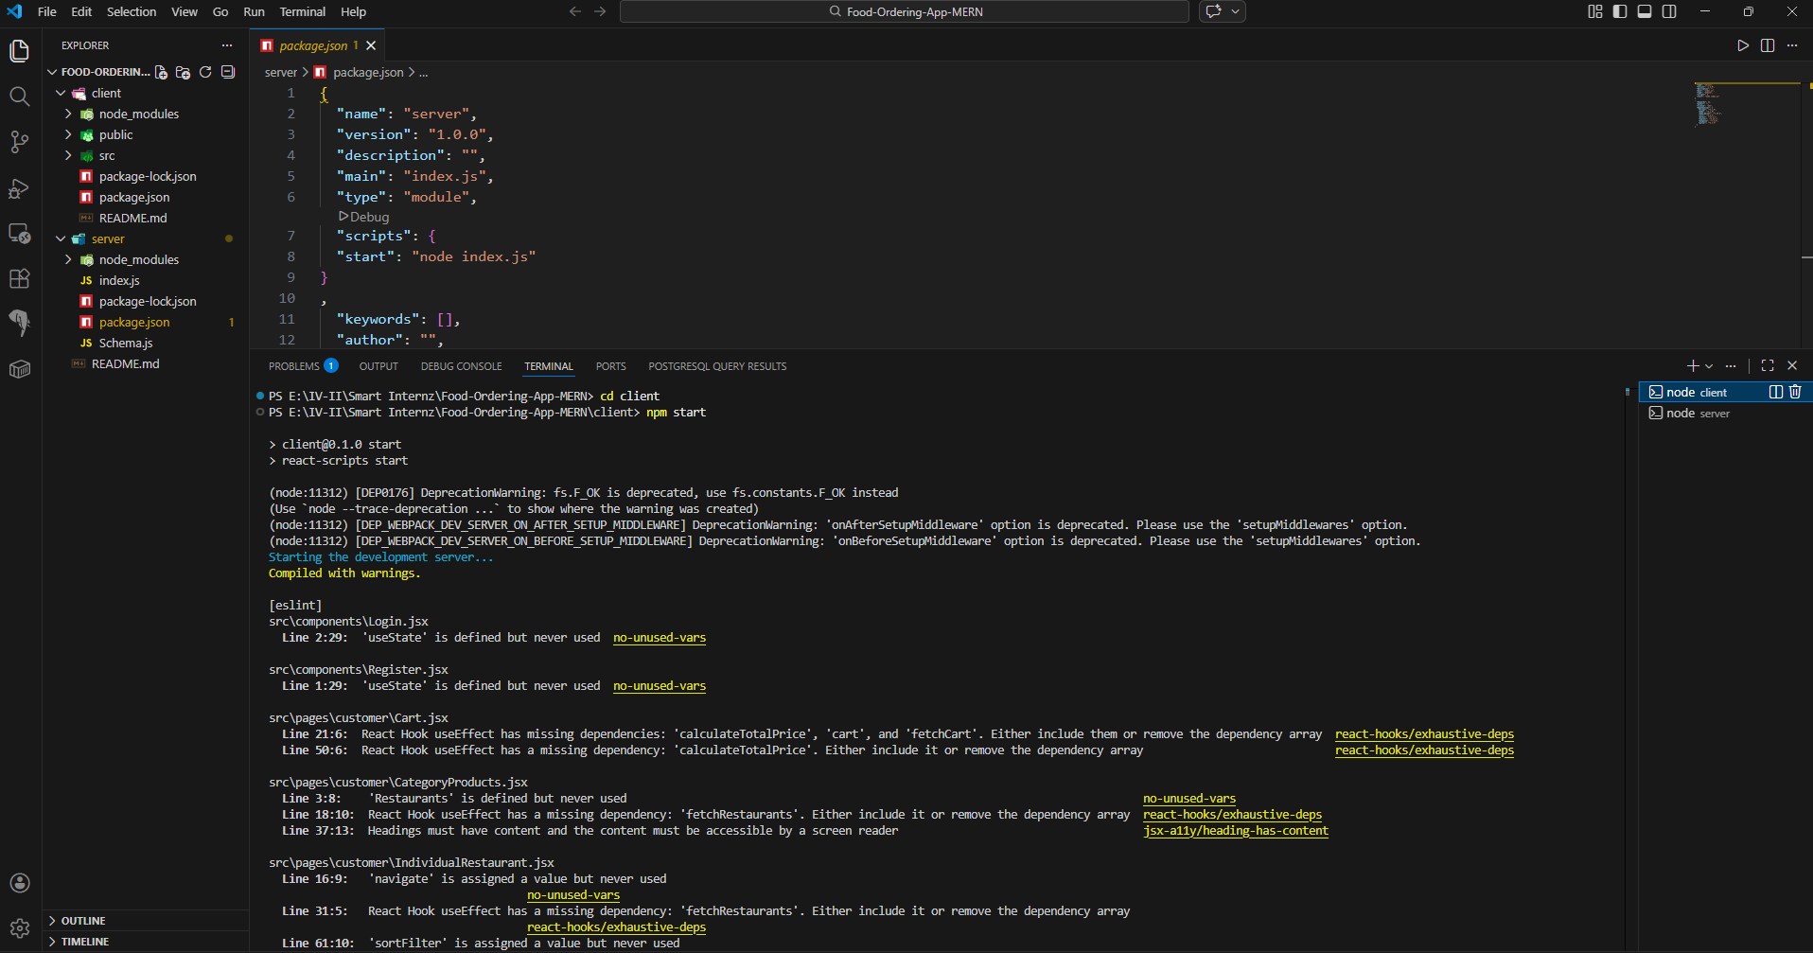
- Bug Fixes: Document major issues (e.g., npm script errors, backend crashes) and how you solved them.

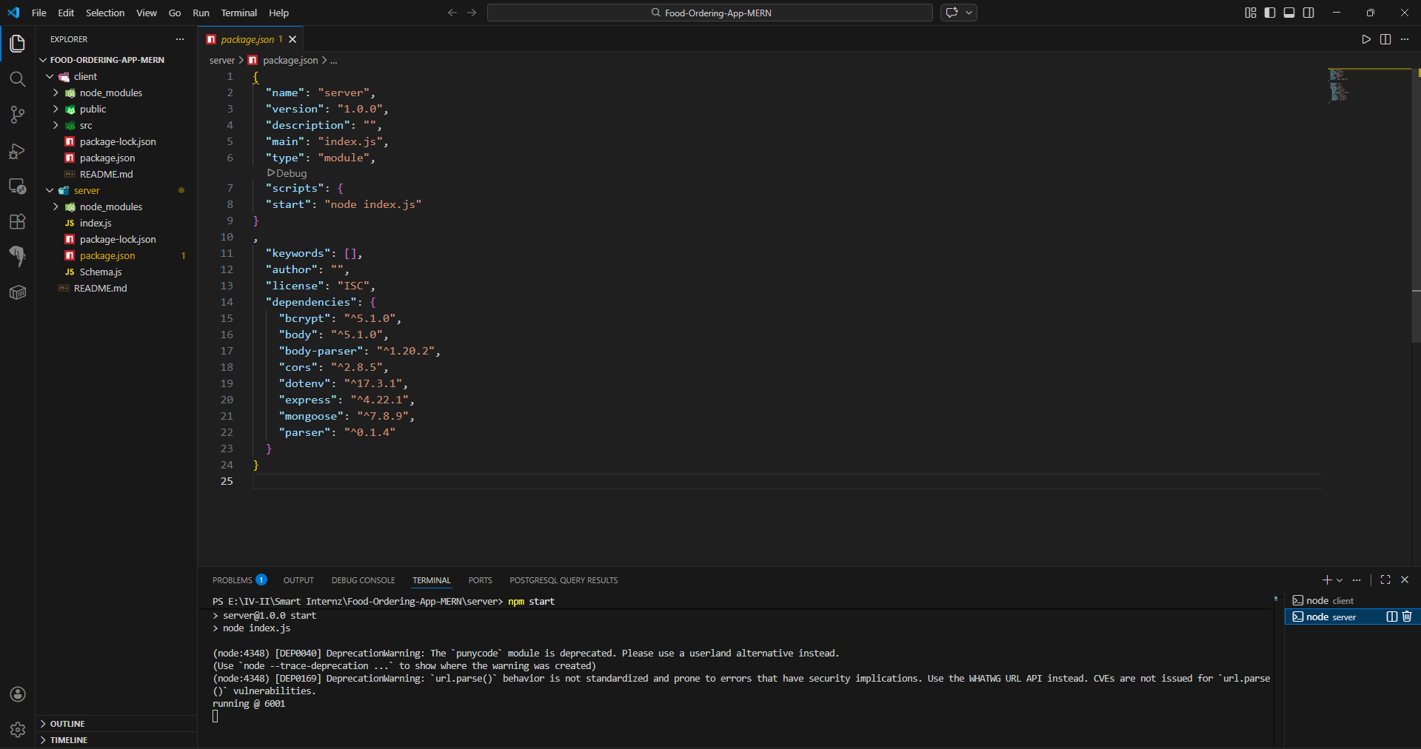

5. Deployment
- Local Deployment: Running on localhost with Node.js.
- Cloud Deployment: Hosting backend on AWS EC2 / Render, frontend on Netlify/Vercel, database on MongoDB Atlas.
- CI/CD (optional): GitHub Actions or manual deployment steps.

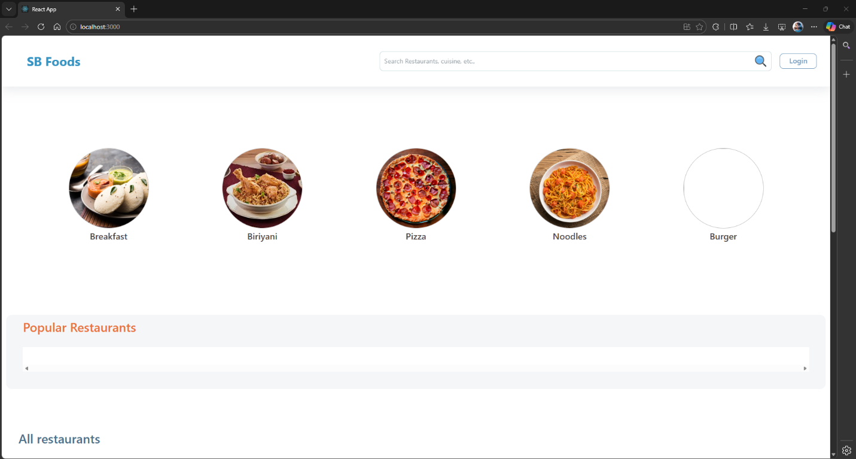
6. Screenshots & Evidence

